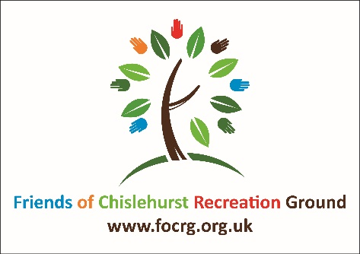
Privacy Policy of the
Friends of Chislehurst Recreation Ground [FOCRG]

FOCRG respects the privacy of our supporters, volunteers and of the visitors to our website and social media. This policy sets out the way we collect data, how we store it, protect it, use it, and what rights you have.

Who are we?

Any references to “Friends of Chislehurst Recreation Ground”, “FOCRG”, “Chislehurst Rocks”, “we” or “us” are to the charity named Friends of Chislehurst Recreation Ground, as registered with the Charity Commission (registration number 1163405).

What personal data we collect and how we use it
If you are a member of FOCRG, we collect your name and those of any family members that wish to be included, address, contact phone numbers and email address and details of any help you say you may be able to give us (eg volunteer at events, fundraise etc) from the completed membership form.

If you are a donor to FOCRG, or a donor or sponsor of Chislehurst Rocks, either by one-off donation or by regular standing order, then we collect your name, business name (if applicable), address, contact phone numbers and email address, and amount from the completed donation form and a gift aid form if relevant.

If you are a sponsor of Chislehurst Rocks we will also ask whether you wish to be listed in festival literature, publicity materials and website or remain anonymous.

If you are a volunteer, we may store emergency contact details.

If you are not a donor but have opted-in to receive our electronic newsletters, we only collect your name and email address.

We have an annual general meeting to which we invite our members and supporters. Most of these invitations are issued by MailChimp and a general invitation is also made by poster on the Recreation Grounds noticeboards.

If you make an application to run or are accepted to run a stallholder or workshop at Chislehurst Rocks or other events that may be run by FOCRG, we collect your name, organisation name, address, contact numbers, Borough registered with (food suppliers), description of your stall/activity, pitch requirements. We are also required to have sight of your public liability insurance and other relevant certificates and licences.

This information is stored locally by the data controller and the treasurer and/or other members of the FOCRG/Chislehurst Rocks committees and/or on a secure cloud system. It undergoes rigorous virus checking routines on a regular basis. Access to your data is strictly guarded by the data controller and the treasurer and by other members of the FOCRG/Chislehurst Rocks committees who have access to the information in order to perform their role.

We send out newsletters to those with email addresses on a regular, but not too frequent, basis by MailChimp. This system allows you to unsubscribe at any time with ease, and your address is automatically removed by the system.
If you are supplying products or services to FOCRG and/or Chislehurst Rocks or other event organised by FOCRG, we will collect your organisation name, contact details, contact name(s) and will record details of all orders placed and payments made.
If you make an application to perform at Chislehurst Rocks on the main and/or community stages, we collect: music genre, age group, number of performers, full contact details, links to your music eg on SoundCloud, details of your website YouTube, Twitter and Facebook sites, any special arrangements necessary. By applying to perform you are agreeing to us using your name, images and social media sites for publicity and other purposes. This information is stored locally by the Music Directors of the event.
If you enter our raffles or competitions we will collect your name and contact number(s). This information is destroyed within 3 months of the end of the event.

Sharing your information
We don’t share information with third parties other than
- HMRC in respect of anyone who donates to FOCRG and completes a gift aid form; we advise the name, address, date and amount of the gift aided donation
- London Borough of Bromley and their contractor, idverde, in respect of stallholders at Chislehurst Rocks and other events we organise in order to comply with licence arrangements. This will include the stallholder’s name, organisation/business name, address, contact numbers, Borough registered with (food suppliers), description of the stall/activity, public liability insurance and other relevant certificates and licences.

Retaining your information
We hold your data only for as long as it is required. If you choose to unsubscribe, then your information is deleted immediately.

What are your rights?
From May 2018 a new European General Data Protection Regulation (GDPR) gives everyone some improved rights as follows:
- Transparency over how we use your personal data (right to be informed),
- Request a copy of the information we hold about you (right of access),
- Update the data we hold about you (right of rectification),
- Ask us to stop using your data (right to restrict processing),
- Ask us to remove your information from our system (right to be forgotten),
- Object to the processing of your data for marketing purposes (right to object),
- Obtain and reuse your personal data for your own purposes (right to data portability),
- Not to be subject to a decision when it is based on automated processing (automated decision making and profiling).

If you would like more information regarding your rights under the data protection law, please see the Information Commissioners Office website at https://ico.org.uk/

You can change your preferences at any time by emailing info@focrg.org.uk
How to contact us
You can contact the data controller by writing to:
The Data Controller, Friends of Chislehurst Recreation Grounds, c/o 3 Willow Vale, Chislehurst BR7 5DF
Or by emailing: info@focrg.org.uk

